**In-Class Exercise1**

**W0461592**

Example of bad design:

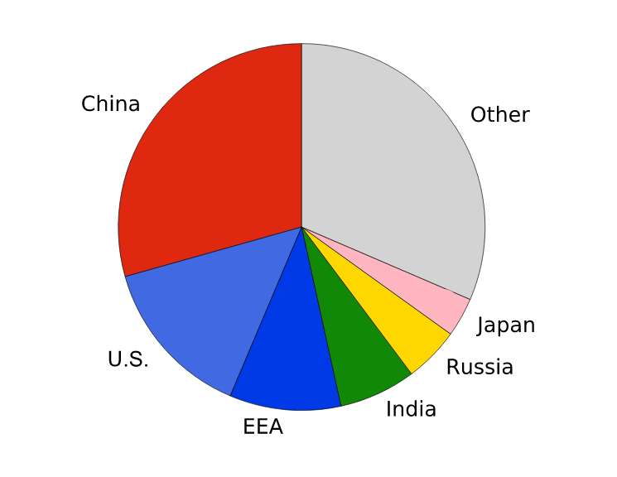

It is considered as a bad design because pie charts are better to use when there are 2-3 items that will makeup a while. Also, in the above pie chart it’s hard to differentiate the size of these parts.

For example, “China” and “other” looks the same to the eye for the user.

Example of a good design:

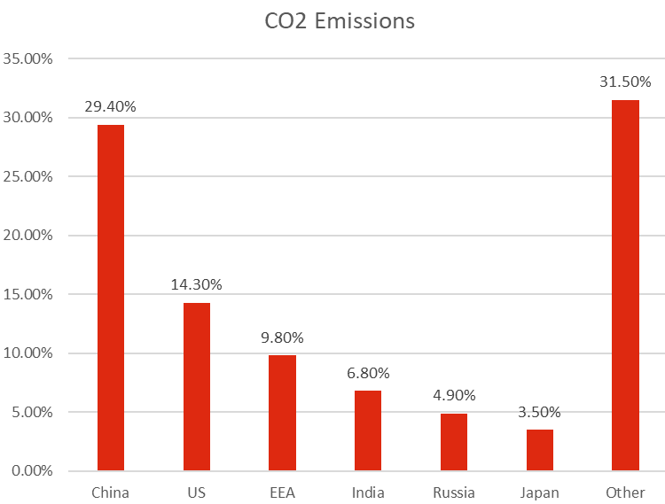

The above bar chart is considered as s good design as it is very easy for the user to differentiate between each item using the bars. By using this design, the user can easily identify the difference between the items “China” and “Other”, as our eyes are more sensitive to the length of the bars than parts of a circle.